ARTIFICIAL INTELLIGENCE LAB

REPORT ASSIGNMENT-2

NAME: SOHAM LAHIRI

CLASS: BCSE UG-III 6TH SEMESTER

ROLL NO: 002210501107

GROUP: A3

SUBMISSION DATE: 22/04/2025

INDEX

S.No. | Problem | Pg. No.
1 | Water Jug Problem | 3
2 | 8 Puzzle Problem | 21
3 | Missionary Cannibals Problem | 41
4 | Maze Problem | 59
5 | Function Optimization | 77

Implement Water Jug Problem using search techniques

Theory:
The Water Jug Problem is a well-known problem in Artificial Intelligence that exemplifies the use of state-space search techniques to solve practical problems. The objective is to determine a sequence of actions that will result in obtaining a specific amount of water using only two jugs with given capacities and an unlimited water supply. This problem demonstrates how a real-world scenario can be modeled and solved using various search algorithms.
The Water Jug Problem can be defined formally as follows:
- Given: Two jugs with capacities AAA and BBB liters, and an unlimited supply of water.
- Goal: Measure exactly CCC liters using the jugs.
The problem is to find a series of operations (fill, empty, pour) that will leave exactly CCC liters of water in either jug.
State Representation
Each state can be represented as a pair (x,y)(x, y)(x,y), where:
- xxx: amount of water in Jug A
- yyy: amount of water in Jug B
Initial State
(0,0)(0, 0)(0,0): Both jugs are empty.
Goal State
Any state (x,y)(x, y)(x,y) where either x=Cx = Cx=C or y=Cy = Cy=C.
Possible Actions
- Fill Jug A to its capacity.
- Fill Jug B to its capacity.
- Empty Jug A.
- Empty Jug B.
- Pour water from Jug A to Jug B until Jug B is full or Jug A is empty.
- Pour water from Jug B to Jug A until Jug A is full or Jug B is empty.

WATER JUG – BREADTH FIRST SEARCH

CODE:
'''Water Jug Problem Solved with BFS''' def bfs(start, capacity, goal):
l = []
visited = set()
parent = {} # Dictionary to track the parent of each node visited.add(start)
u = start
while True: print(u) states = [
(capacity[0], u[1]), # Fill first jug (u[0], capacity[1]), # Fill second jug (0, u[1]), # Empty first jug
(u[0], 0) # Empty second jug
]
# Pour water from first jug to second jug if u[0] + u[1] > capacity[0]:
states.append((capacity[0], u[1] - capacity[0] + u[0]))
states.append((u[0] + u[1], 0))
# Pour water from second jug to first jug if u[1] + u[0] > capacity[1]:
states.append((u[0] - capacity[1] + u[1], capacity[1])) else:
states.append((0, u[0] + u[1]))
for state in states:
if state in l or state in visited: continue
else:
l.insert(0, state)
parent[state] = u # Track the parent
if not l:
break # If no more states to explore, exit loop
u = l.pop() visited.add(u)
if u[0] == goal or u[1] == goal:
print(u)
print("Goal Reached")
pth = reconstruct_path(parent, u, start) print("Path:", pth)
return
print("No Goal Present")
def reconstruct_path(parent, goal, start):
"""Reconstruct the path from goal to start using the parent dictionary."""
path = [goal]
while goal in parent: # Traverse back using the parent dictionary
goal = parent[goal] path.append(goal)
path.reverse() # Reverse the path to get start → goal return path
start = (0, 0)
capacity = (3, 5)
print("Order of Nodes Visited:") bfs(start, capacity, goal) OUTPUT:

Output:
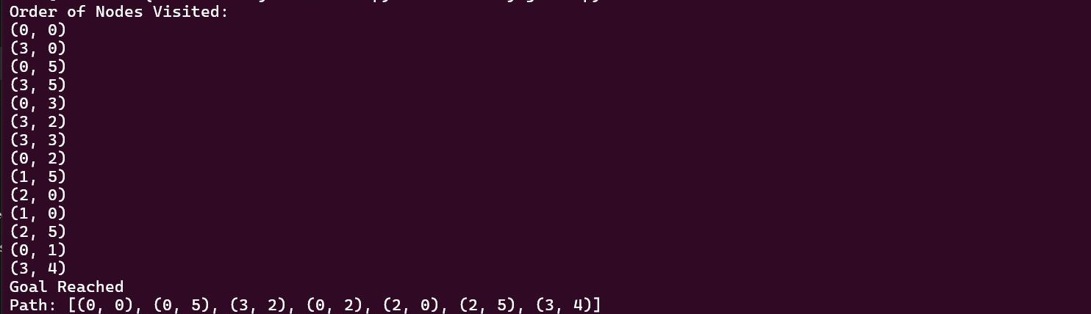

WATER JUG – DEPTH FIRST SEARCH

CODE:
def dfs(start, capacity, goal):
stack = [start] # Use stack for DFS visited = set()
parent = {} visited.add(start)
print(start)
while stack:
u = stack.pop()
if u[0] == goal or u[1] == goal: print(u)
print("Goal Reached")
path = reconstruct_path(parent, u, start) print("Path:", path)
return
# Generate all possible next states states = [
(capacity[0], u[1]), # Fill first ju
(u[0], capacity[1]), # Fill second jug (0, u[1]), # Empty first jug
(u[0], 0), # Empty second jug
]
# Pour from first to second
pour_to_second = min(u[0], capacity[1] - u[1]) states.append((u[0] - pour_to_second, u[1] +pour_to_second))
# Pour from second to first
pour_to_first = min(u[1], capacity[0] - u[0]) states.append((u[0] + pour_to_first, u[1] - pour_to_first))
for state in states:
if state not in visited: stack.append(state) parent[state] = u
visited.add(state) # Mark as visited when added to stack (to avoid duplicates)
print(state) print("No Goal Present")
def reconstruct_path(parent, goal, start): path = [goal]
while goal in parent: goal = parent[goal] path.append(goal)
path.reverse() return path
# Driver code start = (0, 0)
capacity = (3, 5)
goal = 4
print("Order of Nodes Visited:") dfs(start, capacity, goal)

OUTPUT:
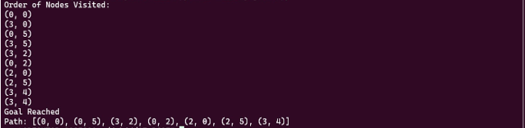

WATER JUG – DEPTH LIMITED SEARCH

CODE:
def get_successors(state, capacity): a, b = state
A, B = capacity successors = []
# Fill A or B successors.append((A, b)) successors.append((a, B))
# Empty A or B successors.append((0, b)) successors.append((a, 0))
# Pour A → B
pour = min(a, B - b) successors.append((a - pour, b + pour))
# Pour B → A
pour = min(b, A - a) successors.append((a + pour, b - pour))
successors
def dls_water_jug(start, capacity, goal_amount, depth_limit): stack = [(start, 0)]
parent = {} visited = set(
print(f"For depth {depth_limit}") while stack:
state, depth = stack.pop()
if state in visited: continue
visited.add(state)
print(f"Visiting: {state} at depth {depth}")
if state[0] == goal_amount or state[1] == goal_amount: path = reconstruct_path(parent, start, state) print("Goal Reached!")
print("Path:", path) return True
if depth < depth_limit:
for next_state in get_successors(state, capacity): if next_state not in visited:
parent[next_state] = state stack.append((next_state, depth + 1))
print("No goal found within depth limit.") return Fals
def reconstruct_path(parent, start, goal): path = [goal]
while goal in parent: goal = parent[goal] path.append(goal)
path.reverse() return path
# Driver start = (0, 0)
capacity = (3, 5)
goal_amount = 4
depth_limit = 5
found = dls_water_jug(start, capacity, goal_amount, depth_limit)
if not found:
print("Goal not found.")

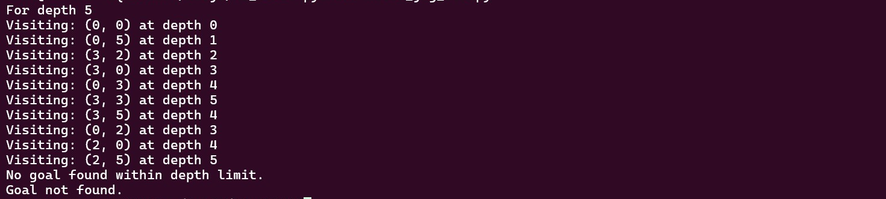
OUTPUT:

WATER JUG – ITERATIVE DEEPENING SEARCH

CODE:
def ids(start, capacity, goal):
def dls(u, depth, limit, visited, parent): if depth > limit:
return False
print(u) visited.add(u)
if u[0] == goal or u[1] == goal: print("Goal Reached")
path = reconstruct_path(parent, u, start) print("Path:", path)
return True
# Generate all possible next states states = [
(capacity[0], u[1]), # Fill first jug (u[0], capacity[1]), # Fill second jug (0, u[1]), # Empty first jug
(u[0], 0)] # Empty second jug
# Pour from first to second
pour_to_second = min(u[0], capacity[1] - u[1]) states.append((u[0] - pour_to_second, u[1] + pour_to_second))
# Pour from second to first
pour_to_first = min(u[1], capacity[0] - u[0]) states.append((u[0] + pour_to_first, u[1] - pour_to_first))
for state in states:
if state not in visited: parent[state] = u
if dls(state, depth + 1, limit, visited, parent): return True
return Fals
depth = 0 while True:
print(f"\nTrying depth limit: {depth}") visited = set()
parent = {}
if dls(start, 0, depth, visited, parent): return
depth += 1
if depth > 50: # Fail-safe to prevent infinite loops print("No Goal Present within depth limit") break
def reconstruct_path(parent, goal, start): path = [goal]
while goal in parent: goal = parent[goal] path.append(goal)
path.reverse() return path
# Driver
start = (0, 0)
capacity = (3, 5)
goal = 4
print("Order of Nodes Visited:")
capacity, goal)

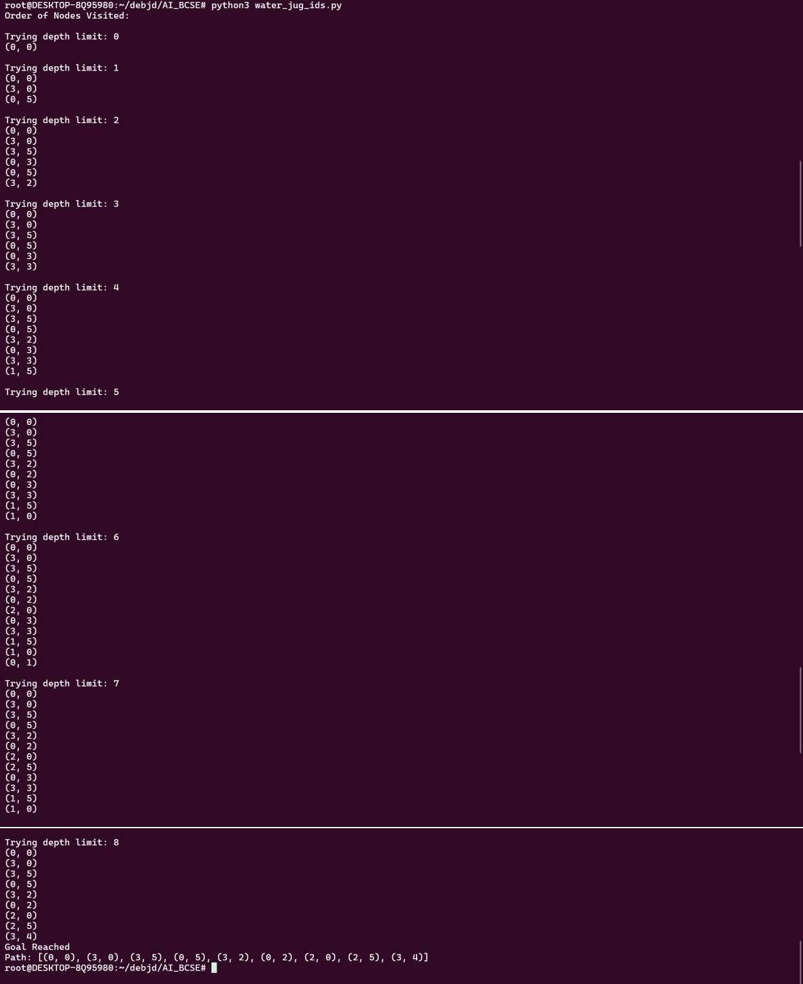
OUTPUT:

WATER JUG – ITERATIVE BROADENING SEARCH

CODE:
def ibs(start, capacity, goal): def get_successors(u):
"""Generate all valid states from the current state u.""" states = [
(capacity[0], u[1]), # Fill first jug (u[0], capacity[1]), # Fill second jug (0, u[1]), # Empty first jug
(u[0], 0),] # Empty second jug
# Pour from first to second
pour_to_second = min(u[0], capacity[1] - u[1]) states.append((u[0] - pour_to_second, u[1] + pour_to_second))
# Pour from second to first
pour_to_first = min(u[1], capacity[0] - u[0]) states.append((u[0] + pour_to_first, u[1] - pour_to_first))
return states
while True:
print(f"\nFor Breadth {b}") visited = set()
parent = {} l = [start]
visited.add(start)
while l:
u = l.pop(0) print(u)
if u[0] == goal or u[1] == goal: print("Goal Reached")
path = reconstruct_path(parent, u, start) print("Path:", path)
return
successors = get_successors(u) count = 0
for state in successors: if state not in visited:
visited.add(state)
parent[state] = u l.append(state) count += 1
if count == b: break
b += 1
if b > 20: # Avoid infinite loop
print("No Goal Present within breadth limit") break
def reconstruct_path(parent, goal, start): path = [goal]
while goal in parent: goal = parent[goal] path.append(goal)
path.reverse() return path
# Driver
start = (0, 0)
capacity = (3, 5)
goal = 4
print("Order of Nodes Visited:") ibs(start, capacity, goal)

OUTPUT:
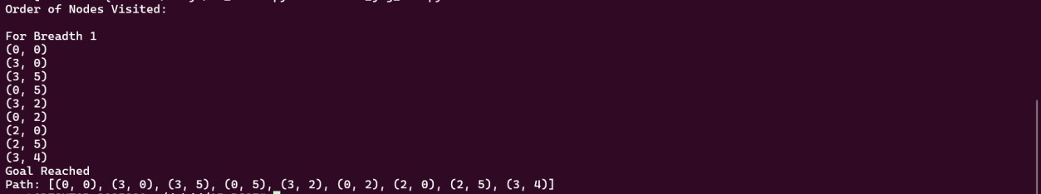

WATER JUG – BEST FIRST SEARCH

CODE:
import heapq
def heuristic(state, goal):
"""Heuristic: Greedy estimate of closeness to goal.""" return min(abs(state[0] - goal), abs(state[1] - goal))
def get_successors(state, capacity):
"""Generate all possible successors (states) from the current state."""
a, b = state
A, B = capacity successors = set()
# Fill either jug successors.add((A, b)) successors.add((a, B))
# Empty either jug successors.add((0, b)) successors.add((a, 0))
# Pour from A to B pour = min(a, B - b)
successors.add((a - pour, b + pour))
# Pour from B to A pour = min(b, A - a)
successors.add((a + pour, b - pour)) return list(successors)
def best_first_water_jug(start, capacity, goal): pq = []
visited = set() parent = {}
# Best-first uses heuristic only heapq.heappush(pq, (heuristic(start, goal), start))
while pq:
_, state = heapq.heappop(pq)
if state in visited: continue
print(f"Visiting: {state}") visited.add(state)
if state[0] == goal or state[1] == goal: print("Goal Reached!")
path = reconstruct_path(parent, start, state) print("Path:", path)
return
for next_state in get_successors(state, capacity): if next_state not in visited:
heapq.heappush(pq, (heuristic(next_state, goal), next_state))
parent[next_state] = state print("No solution found.")
def reconstruct_path(parent, start, goal): path = [goal]
while goal in parent: goal = parent[goal] path.append(goal)
path.reverse() return path
# Driver start = (0, 0)
capacity = (3, 5)
goal = 4
print("Order of Nodes visited:")
best_first_water_jug(start, capacity, goal)

OUTPUT:
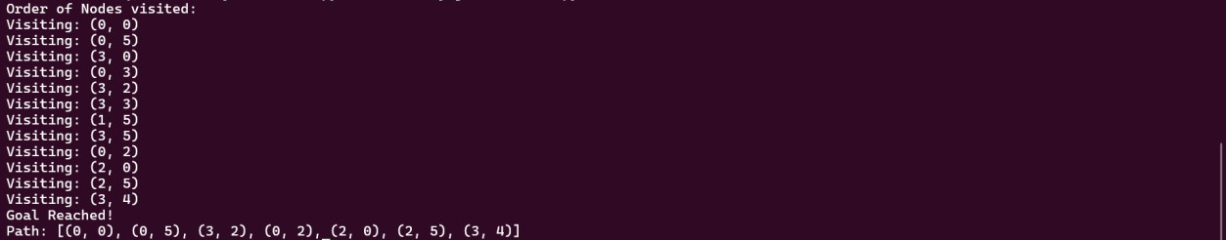

WATER JUG – UNIFORM COST SEARCH

CODE:
import heapq
def get_successors(state, capacity): a, b = state
A, B = capacity successors = []
# Fill Jug A or Jug B successors.append(((A, b), 1)) # Fill A successors.append(((a, B), 1)) # Fill B
# Empty Jug A or Jug B successors.append(((0, b), 1)) # Empty A successors.append(((a, 0), 1)) # Empty B
# Pour A → B
pour = min(a, B - b)
successors.append(((a - pour, b + pour), 1))
# Pour B → A
pour = min(b, A - a)
successors.append(((a + pour, b - pour), 1)) return successors
def water_jug_ucs(start, capacity, goal): pq = []
parent = {} cost_so_far = {} visited = set()
heapq.heappush(pq, (0, start))
cost_so_far[start] = 0
while pq:
current_cost, state = heapq.heappop(pq)
if state in visited: continue
print(f"Visiting: {state} with cost {current_cost}") visited.add(state)
if state[0] == goal or state[1] == goal: print("Goal Reached!")
path = reconstruct_path(parent, start, state) print("Path:", path)
return
for next_state, cost in get_successors(state, capacity): new_cost = current_cost + cost
if next_state not in cost_so_far or new_cost < cost_so_far[next_state]:
cost_so_far[next_state] = new_cost heapq.heappush(pq, (new_cost, next_state)) parent[next_state] = state
print("No solution found.")
def reconstruct_path(parent, start, goal): path = [goal]
while goal in parent: goal = parent[goal] path.append(goal)
path.reverse()
path
# Driver
start = (0, 0)
capacity = (3, 5)
goal = 4
print("Order of Nodes visited:") water_jug_ucs(start, capacity, goal)

OUTPUT:
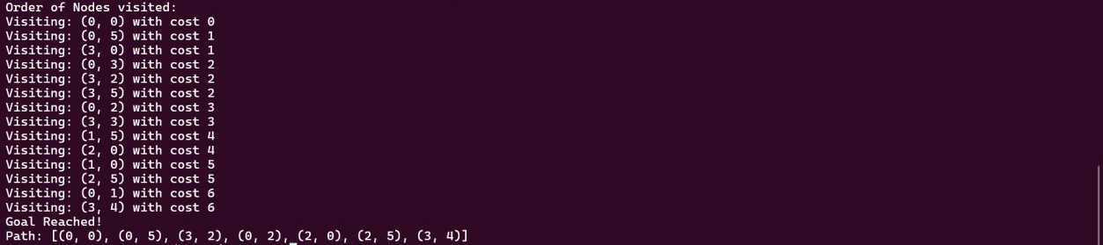

WATER JUG – A* SEARCH

CODE:
import heapq
def heuristic(state, goal):
"""Heuristic: Minimum difference from goal in either jug."""
return min(abs(state[0] - goal), abs(state[1] - goal))
def get_successors(u, capacity): """Generate all possible next states.""" successors = []
# Fill Jug A or B successors.append((capacity[0], u[1])) successors.append((u[0], capacity[1]))
# Empty Jug A or B successors.append((0, u[1])) successors.append((u[0], 0))
# Pour A -> B
pour = min(u[0], capacity[1] - u[1])
successors.append((u[0] - pour, u[1] + pour))
# Pour B -> A
pour = min(u[1], capacity[0] - u[0]) successors.append((u[0] + pour, u[1] - pour))
return successor
def astar_water_jug(start, capacity, goal): pq = []
heapq.heappush(pq, (heuristic(start, goal), 0, start)) visited = set()
parent = {}
g_score = {start: 0}
while pq:
f, g, u = heapq.heappop(pq)
print(f"Visiting {u} with cost {g}") visited.add(u)
if u[0] == goal or u[1] == goal: print("Goal Reached!")
path = reconstruct_path(parent, start, u) print("Path:", path)
return
for v in get_successors(u, capacity): if v not in visited:
temp_g = g + 1
if v not in g_score or temp_g < g_score[v]: g_score[v] = temp_g
f_score = temp_g + heuristic(v, goal) heapq.heappush(pq, (f_score, temp_g, v)) parent[v] = u
print("No solution found.")
def reconstruct_path(parent, start, goal): path = [goal]
while goal in parent: goal = parent[goal] path.append(goal)
path.reverse() return path
start = (0, 0)
capacity = (3, 5)
goal = 4
print("Order of Nodes visited:")
astar_water_jug(start, capacity, goal)

OUTPUT:
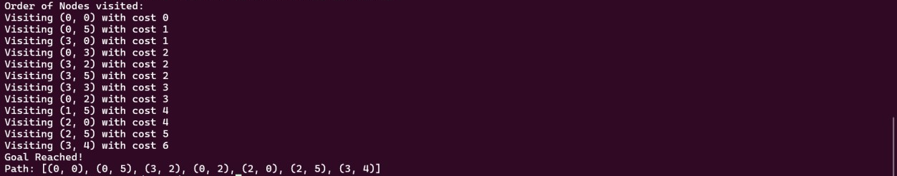

8 PUZZLE PROBLEM INPUT

Initially, position of tiles is
start = (1, 3, 5,
4, 2, 0,
7, 8, 6)
I have considered the blank tile as 0 for easy usage in arrays.

Theory:
The 8 Puzzle Problem is a classic example in the field of Artificial Intelligence and search algorithms. It involves a 3x3 board with eight numbered tiles and one empty space. The objective is to reach a specified goal configuration by sliding tiles into the empty space. This problem illustrates important AI concepts such as state-space representation, heuristic search, and optimal pathfinding.
The 8 Puzzle consists of a 3x3 grid containing eight tiles numbered from 1 to 8 and a single blank space. A tile adjacent to the blank space can be moved into it. The goal is to transform an initial configuration into a goal configuration by a sequence of valid moves.
State Representation
A state can be represented as a 3x3 matrix or a linear array of 9 elements, with each element indicating the position of a tile or the blank (often denoted as 0).
Initial State: Any random arrangement of the tiles and the blank.
Goal State: A specific arrangement
Operators / Actions
- Move the blank tile up, down, left, or right, if the move is within bounds.

8 PUZZLE PROBLEM – BREADTH FIRST SEARCH

CODE:
from collections import deque
def bfs_8_puzzle(start, goal): def get_neighbors(state):
neighbors = []
index = state.index(0)
row, col = divmod(index, 3)
moves = [(-1, 0), (1, 0), (0, -1), (0, 1)] # Up, Down, Left, Right
for dr, dc in moves:
r, c = row + dr, col + dc
if 0 <= r < 3 and 0 <= c < 3: new_idx = r * 3 + c new_state = list(state)
new_state[index], new_state[new_idx] = new_state[new_idx], new_state[index]
neighbors.append(tuple(new_state)) return neighbors
visited = set()
= deque([start]) parent = {} visited.add(start)
print("Order of Nodes Visited:")
while queue:
current = queue.popleft() print(current)
if current == goal: print("Goal Reached")
path = reconstruct_path(parent, current, start) print("Path to Goal:")
for step in path: print(step)
retur
for neighbor in get_neighbors(current): if neighbor not in visited:
visited.add(neighbor) parent[neighbor] = current queue.append(neighbor)

print("No Goal Present")
def reconstruct_path(parent, goal, start): path = [goal]
while goal in parent: goal = parent[goal] path.append(goal)
path.reverse() return path
# Example usage: start = (1, 3, 5,
4, 2, 0,
7, 8, 6)
goal = (1, 2, 3,
4, 5, 6,
7, 8, 0)
bfs_8_puzzle(start, goal)

Output:
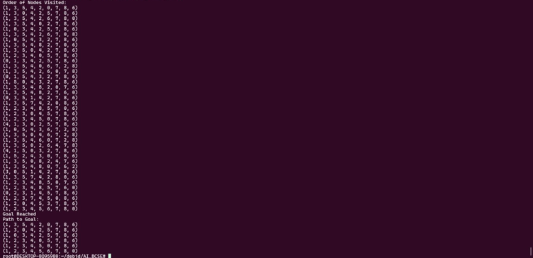

8 PUZZLE PROBLEM – DEPTH FIRST SEARCH

CODE:
def get_neighbors(state): neighbors = []
index = state.index(0)
row, col = divmod(index, 3)
moves = [(-1, 0), (1, 0), (0, -1), (0, 1)] # Up, Down, Left,
Right
for dr, dc in moves:
r, c = row + dr, col + dc
if 0 <= r < 3 and 0 <= c < 3: new_idx = r * 3 + c new_state = list(state)
new_state[index], new_state[new_idx] = new_state[new_idx], new_state[index]
neighbors.append(tuple(new_state)) return neighbors
def reconstruct_path(parent, goal, start): path = [goal]
while goal in parent: goal = parent[goal]
path.append(goal) path.reverse()
return path
def dfs_8_puzzle(start, goal): stack = [start]
visited = set() parent = {}
print("Order of Nodes Visited:")
while stack:
current = stack.pop() if current in visited:
continue visited.add(current) print(current)
if current == goal: print("Goal Reached")
path = reconstruct_path(parent, current, start) print("Path to Goal:")
for step in path: print(step)
return
for neighbor in reversed(get_neighbors(current)): if neighbor not in visited:
parent[neighbor] = current stack.append(neighbor)

print("No Goal Present") # Example usage:
start = (1, 3, 5,
4, 2, 0,
7, 8, 6)
goal = (1, 2, 3,
4, 5, 6,
7, 8, 0)
dfs_8_puzzle(start, goal)

Output:
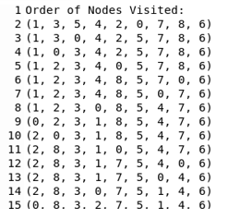
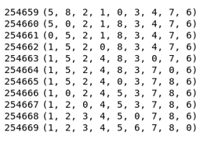

8 PUZZLE PROBLEM – DEPTH LIMITED SEARCH

CODE:
def get_neighbors(state): neighbors = []
index = state.index(0)
row, col = divmod(index, 3)
moves = [(-1, 0), (1, 0), (0, -1), (0, 1)] # Up, Down, Left,
Right
for dr, dc in moves:
r, c = row + dr, col + dc
if 0 <= r < 3 and 0 <= c < 3: new_idx = r * 3 + c new_state = list(state)
new_state[index], new_state[new_idx] = new_state[new_idx], new_state[index]
neighbors.append(tuple(new_state)) return neighbors
def reconstruct_path(parent, goal, start): path = [goal]
while goal in parent: goal = parent[goal]
path.append(goal) path.reverse()
return path
def dls_8_puzzle(start, goal, limit): def recursive_dls(node, depth):
visited.add(node) print(node)
if node == goal: return True
if depth == 0: return False
for neighbor in get_neighbors(node): if neighbor not in visited:
parent[neighbor] = node
if recursive_dls(neighbor, depth - 1): return True
return False
visited = set() parent = {}
print("Order of Nodes Visited:") if recursive_dls(start, limit):
print("Goal Reached")
path = reconstruct_path(parent, goal, start) print("Path to Goal:")
for step in path: print(step)
else:
print("No Goal Present within depth limit") # Example usage:
start = (1, 3, 5,
4, 2, 0,
7, 8, 6)
goal = (1, 2, 3,
4, 5, 6,
7, 8, 0)
dls_8_puzzle(start, goal,5)

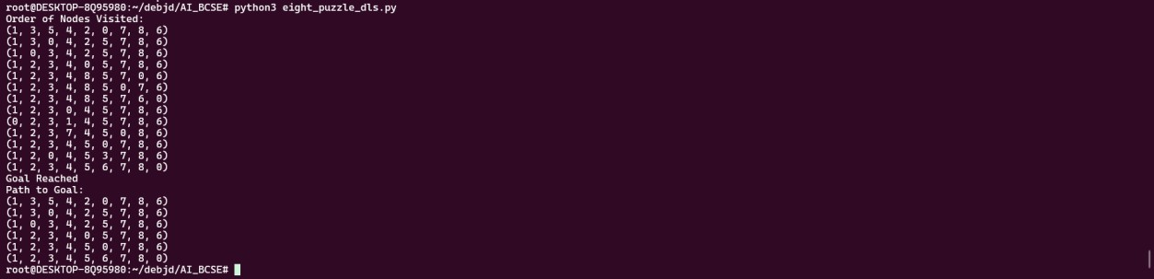
OUTPUT:

8 PUZZLE PROBLEM – ITERATIVE DEEPENING SEARCH

CODE:
def get_neighbors(state): neighbors = []
index = state.index(0)
row, col = divmod(index, 3)
moves = [(-1, 0), (1, 0), (0, -1), (0, 1)] # Up, Down, Left,
Right
for dr, dc in moves:
r, c = row + dr, col + dc
if 0 <= r < 3 and 0 <= c < 3: new_idx = r * 3 + c new_state = list(state)
new_state[index], new_state[new_idx] = new_state[new_idx], new_state[index]
neighbors.append(tuple(new_state)) return neighbors
def reconstruct_path(parent, goal, start): path = [goal]
while goal in parent: goal = parent[goal]
path.append(goal) path.reverse()
return path
def ids_8_puzzle(start, goal, max_depth=20): for depth in range(max_depth):
print(f"Depth Limit: {depth}") visited = set()
parent = {}
def dls(node, limit): visited.add(node) print(node)
if node == goal: return True
if limit == 0: return False
for neighbor in get_neighbors(node): if neighbor not in visited:
parent[neighbor] = node if dls(neighbor, limit - 1):
return True return False
if dls(start, depth): print("Goal Reached")
path = reconstruct_path(parent, goal, start) print("Path to Goal:")
for step in path: print(step)
return
print("No Goal Found within max depth") # Example usage:
start = (1, 3, 5,
4, 2, 0,
7, 8, 6)
goal = (1, 2, 3,
4, 5, 6,
7, 8, 0)
ids_8_puzzle(start, goal)

OUTPUT:
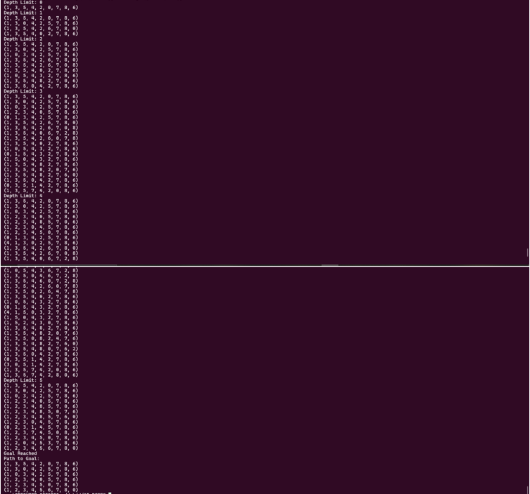

8 PUZZLE PROBLEM – ITERATIVE BROADENING SEARCH

CODE:
def get_neighbors(state): neighbors = []
index = state.index(0)
row, col = divmod(index, 3)
moves = [(-1, 0), (1, 0), (0, -1), (0, 1)] # Up, Down, Left,Right
for dr, dc in moves:
r, c = row + dr, col + dc
if 0 <= r < 3 and 0 <= c < 3: new_idx = r * 3 + c new_state = list(state)
new_state[index], new_state[new_idx] = new_state[new_idx], new_state[index]
neighbors.append(tuple(new_state)) return neighbors
def reconstruct_path(parent, goal, start): path = [goal]
while goal in parent: goal = parent[goal]
path.append(goal) path.reverse()
return path
def ibs_8_puzzle(start, goal, max_breadth=10): def limited_bfs(start, breadth_limit):
visited = set()
queue = deque([start]) parent = {} visited.add(start)
print("Order of Nodes Visited:")
while queue:
current = queue.popleft() print(current)
if current == goal: print("Goal Reached")
path = reconstruct_path(parent, current, start) print("Path to Goal:")
for step in path: print(step)
return True
neighbors = get_neighbors(current)[:breadth_limit]
for neighbor in neighbors: if neighbor not in visited:
visited.add(neighbor) parent[neighbor] = current queue.append(neighbor)
return False
for breadth in range(1, max_breadth + 1): print(f"\nTrying with Breadth Limit: {breadth}") if limited_bfs(start, breadth):
return
print("No Goal Found within breadth limits") # Example usage:
start = (1, 3, 5,
4, 2, 0,
7, 8, 6)
goal = (1, 2, 3,
4, 5, 6,
7, 8, 0
ibs_8_puzzle(start, goal)

Output:
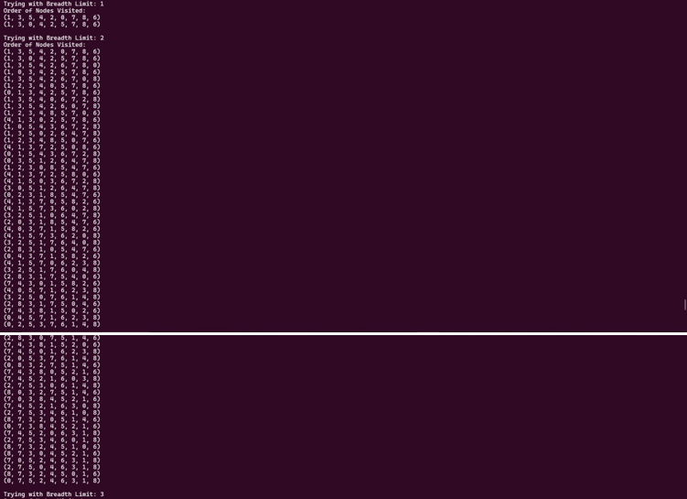

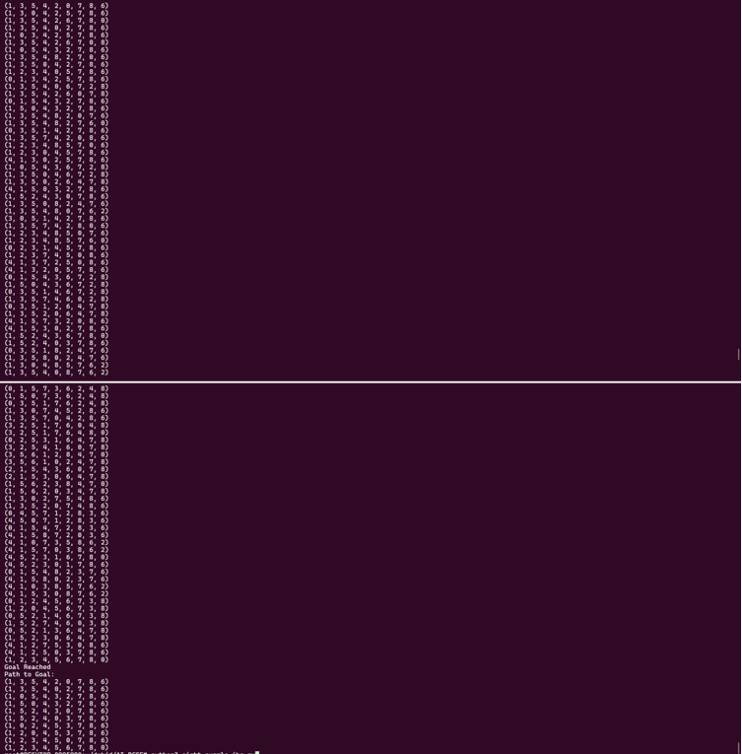

8 PUZZLE PROBLEM – BEST FIRST SEARCH

CODE:
import heapq
def get_neighbors(state): neighbors = []
index = state.index(0)
row, col = divmod(index, 3)
moves = [(-1, 0), (1, 0), (0, -1), (0, 1)]
for dr, dc in moves:
r, c = row + dr, col + dc
if 0 <= r < 3 and 0 <= c < 3: new_idx = r * 3 + c new_state = list(state)
new_state[index], new_state[new_idx] = new_state[new_idx], new_state[index]
neighbors.append(tuple(new_state)) return neighbors
def reconstruct_path(parent, goal, start): path = [goal]
while goal in parent:
goal = parent[goal] path.append(goal)
path.reverse() return path
def manhattan_distance(state, goal): distance = 0
for num in range(1, 9): idx1 = state.index(num) idx2 = goal.index(num) x1, y1 = divmod(idx1, 3) x2, y2 = divmod(idx2, 3)
distance += abs(x1 - x2) + abs(y1 - y2) return distanc
def print_board(state): for i in range(0, 9, 3):
print(state[i:i+3]) print()
def best_first_search(start, goal): open_list = []
heapq.heappush(open_list, (manhattan_distance(start, goal), start))
visited = set() parent = {}
print("Order of Nodes Visited:")
while open_list:
_, current = heapq.heappop(open_list)

if current in visited: continue
visited.add(current) print_board(current
if current == goal: print("Goal Reached")
path = reconstruct_path(parent, current, start) print("Path to Goal:")
for step in path: print_board(step)
return
for neighbor in get_neighbors(current): if neighbor not in visited:
parent[neighbor] = current heapq.heappush(open_list,
(manhattan_distance(neighbor, goal), neighbor))
print("No Goal Found") start = (1, 3, 5,
4, 2, 0,
7, 8, 6)
goal = (1, 2, 3,
4, 5, 6,
7, 8, 0)
best_first_search(start, goal)

Output:
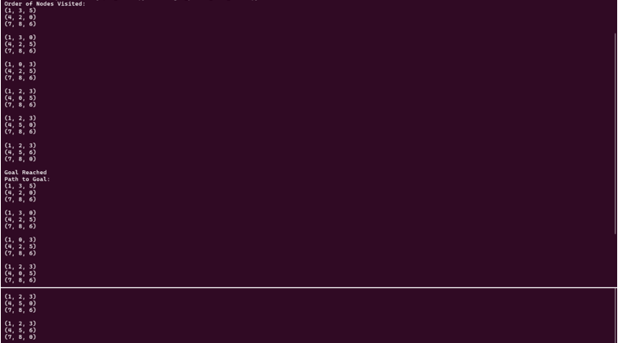

8 PUZZLE PROBLEM – UNIFORM COST SEARCH

CODE:
import heapq
def get_neighbors(state): neighbors = []
index = state.index(0)
row, col = divmod(index, 3)
moves = [(-1, 0), (1, 0), (0, -1), (0, 1)]
for dr, dc in moves:
r, c = row + dr, col + dc
if 0 <= r < 3 and 0 <= c < 3: new_idx = r * 3 + c new_state = list(state)
new_state[index], new_state[new_idx] = new_state[new_idx], new_state[index]
neighbors.append(tuple(new_state)) return neighbors
def reconstruct_path(parent, goal, start): path = [goal]
while goal in parent:
goal = parent[goal] path.append(goal)
path.reverse() return path
def manhattan_distance(state, goal): distance = 0
for num in range(1, 9): idx1 = state.index(num) idx2 = goal.index(num) x1, y1 = divmod(idx1, 3) x2, y2 = divmod(idx2, 3)
distance += abs(x1 - x2) + abs(y1 - y2) return distance
def print_board(state): for i in range(0, 9, 3):
print(state[i:i+3]) print()
def ucs_8_puzzle(start, goal): open_list = [] heapq.heappush(open_list, (0, start)) visited = set(
parent = {} cost = {start: 0}
print("Order of Nodes Visited:")
while open_list:
current_cost, current = heapq.heappop(open_list)
if current in visited: continue
visited.add(current) print_board(current)
if current == goal: print("Goal Reached")
path = reconstruct_path(parent, current, start) print("Path to Goal:")
for step in path: print_board(step)
return
for neighbor in get_neighbors(current)
new_cost = current_cost + 1 # Each move has uniform cost
if neighbor not in cost or new_cost < cost[neighbor]: cost[neighbor] = new_cost
parent[neighbor] = current heapq.heappush(open_list, (new_cost, neighbor))
print("No Goal Found") start = (1, 3, 5,
4, 2, 0,
7, 8, 6)
goal = (1, 2, 3,
4, 5, 6,
7, 8, 0)
ucs_8_puzzle(start, goal)

OUTPUT:
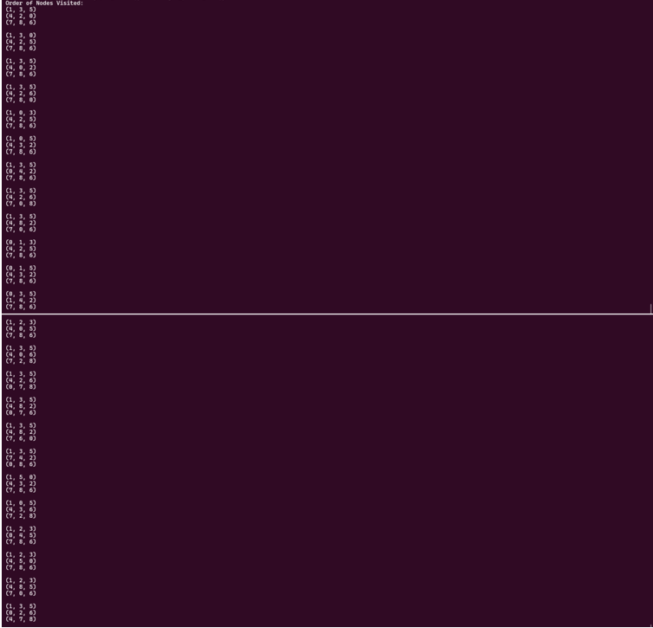

8 PUZZLE PROBLEM – A* SEARCH

CODE:
import heapq
def get_neighbors(state): neighbors = []
index = state.index(0)
row, col = divmod(index, 3)
moves = [(-1, 0), (1, 0), (0, -1), (0, 1)]
for dr, dc in moves:
r, c = row + dr, col + dc
if 0 <= r < 3 and 0 <= c < 3: new_idx = r * 3 + c new_state = list(state)
new_state[index], new_state[new_idx] = new_state[new_idx], new_state[index]
neighbors.append(tuple(new_state)) return neighbors
def reconstruct_path(parent, goal, start): path = [goal]
while goal in parent:
goal = parent[goal] path.append(goal)
path.reverse() return path
def manhattan_distance(state, goal): distance = 0
for num in range(1, 9): idx1 = state.index(num) idx2 = goal.index(num) x1, y1 = divmod(idx1, 3) x2, y2 = divmod(idx2, 3)
distance += abs(x1 - x2) + abs(y1 - y2) return distance
def print_board(state): for i in range(0, 9, 3):
print(state[i:i+3]) print()
def a_star_8_puzzle(start, goal): open_list = []
heapq.heappush(open_list, (manhattan_distance(start, goal), 0, start))
visited = set() parent = {} cost = {start: 0}
print("Order of Nodes Visited:")
while open_list:
f, g, current = heapq.heappop(open_list)

if current in visited: continue
visited.add(current) print_board(current)
if current == goal: print("Goal Reached")
path = reconstruct_path(parent, current, start) print("Path to Goal:")
for step in path: print_board(step)
return
for neighbor in get_neighbors(current):
goal)
new_cost = g + 1
if neighbor not in cost or new_cost < cost[neighbor]: cost[neighbor] = new_cost
parent[neighbor] = current
f_score = new_cost + manhattan_distance(neighbor,
heapq.heappush(open_list, (f_score, new_cost,
neighbor))
print("No Goal Found") start = (1, 3, 5,
4, 2, 0,
7, 8, 6)
goal = (1, 2, 3,
4, 5, 6,
7, 8, 0)
a_star_8_puzzle(start, goal)

Output:
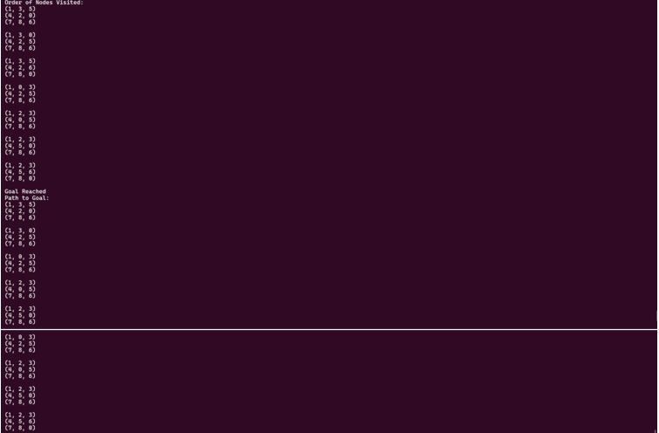

MISSIONARY CANNIBALS PROBLEM INPUT

Problem Summary:
• 3 missionaries and 3 cannibals must cross a river using a boat.
• Boat can carry 1 or 2 people at a time.
• At any point, missionaries must not be outnumbered by cannibals on either bank.
State Representation:
Each state is a tuple:
(m_left, c_left, boat_position)
• m_left: missionaries on left bank
• c_left: cannibals on left bank
• boat_position: 0 if boat on left, 1 if boat on right Start: (3, 3, 0)
Goal: (0, 0, 1)

MISSIONARY CANNIBALS PROBLEM – BREADTH FIRST SEARCH

CODE:
def is_valid(state): m_left, c_left, _ = state m_right = 3 - m_left c_right = 3 - c_left
if not (0 <= m_left <= 3 and 0 <= c_left <= 3): return False
if m_left > 0 and m_left < c_left: return False
if m_right > 0 and m_right < c_right: return False
return True
def get_successors(state): m, c, b = state
moves = [(1,0), (2,0), (0,1), (0,2), (1,1)]
successors = []
for dm, dc in moves: if b == 0:
new_state = (m - dm, c - dc, 1) else:
new_state = (m + dm, c + dc, 0)
if is_valid(new_state): successors.append(new_state)
return successors
def reconstruct_path(parent, goal, start): path = [goal]
while goal in parent: goal = parent[goal] path.append(goal)
path.reverse() return path
def print_path(path): print("Path to Goal:") for step in path:
print(step)
from collections import deque
def bfs_mc(start, goal): visited = set()
queue = deque([start]) parent = {}
print("Order of Nodes Visited:") visited.add(start)
while queue:
current = queue.popleft() print(current)
if current == goal: print("Goal Reached")
path = reconstruct_path(parent, current, start) print_path(path)
return
for neighbor in get_successors(current): if neighbor not in visited:
visited.add(neighbor) parent[neighbor] = current queue.append(neighbor)

print("No Goal Found") start = (3, 3, 0)
goal = (0, 0, 1) bfs_mc(start, goal)

OUTPUT:
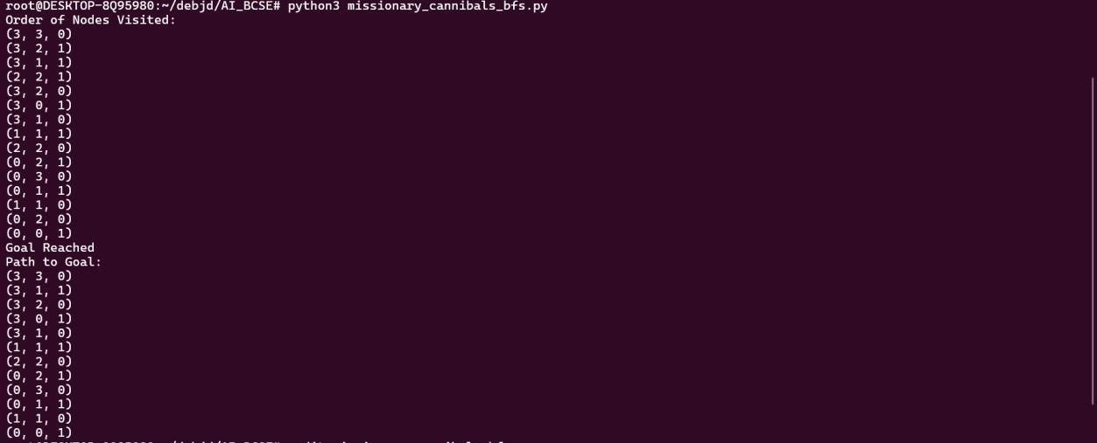

MISSIONARY CANNIBALS PROBLEM – DEPTH FIRST SEARCH

CODE:
def is_valid(state): m_left, c_left, _ = state m_right = 3 - m_left c_right = 3 - c_left
if not (0 <= m_left <= 3 and 0 <= c_left <= 3): return False
if m_left > 0 and m_left < c_left: return False
if m_right > 0 and m_right < c_right: return False
return True
def get_successors(state): m, c, b = state
moves = [(1,0), (2,0), (0,1), (0,2), (1,1)]
successors = []
for dm, dc in moves: if b == 0:
new_state = (m - dm, c - dc, 1) else:
new_state = (m + dm, c + dc, 0)
if is_valid(new_state): successors.append(new_state)
return successors
def reconstruct_path(parent, goal, start): path = [goal]
while goal in parent: goal = parent[goal] path.append(goal)
path.reverse() return pat
def print_path(path): print("Path to Goal:") for step in path:
print(step)
def dfs_mc(start, goal): stack = [start]
visited = set() parent = {}
print("Order of Nodes Visited:")
while stack:
current = stack.pop() if current in visited:
continue visited.add(current) print(current)
if current == goal: print("Goal Reached")
path = reconstruct_path(parent, current, start) print_path(path)
return
for neighbor in reversed(get_successors(current)): if neighbor not in visited:
parent[neighbor] = current stack.append(neighbor)
print("No Goal Found") start = (3, 3, 0)
goal = (0, 0, 1)
dfs_mc(start, goal)

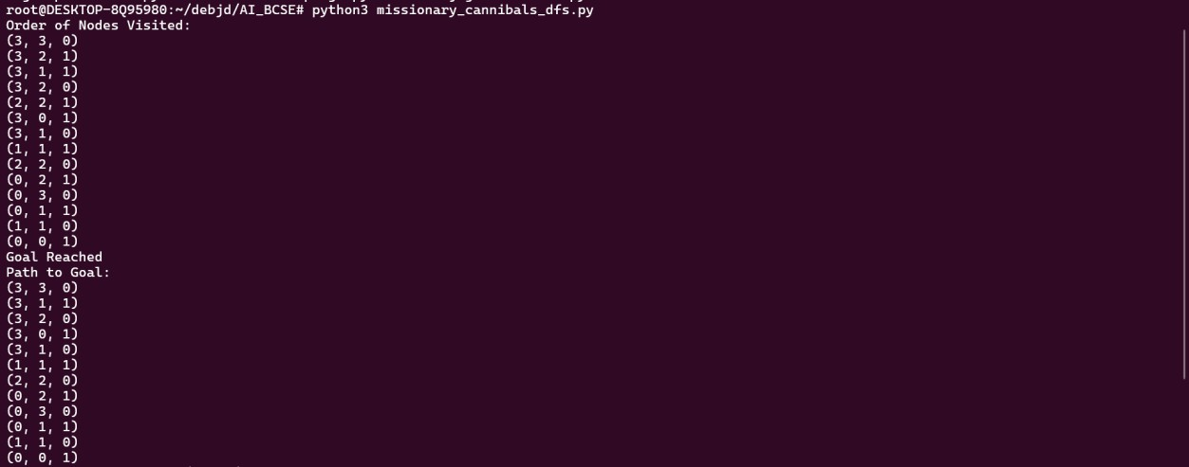
OUTPUT:

MISSIONARY CANNIBALS PROBLEM – DEPTH LIMITED SEARCH

CODE:
def is_valid(state): m_left, c_left, _ = state m_right = 3 - m_left c_right = 3 - c_left
if not (0 <= m_left <= 3 and 0 <= c_left <= 3): return False
if m_left > 0 and m_left < c_left: return False
if m_right > 0 and m_right < c_right: return False
return True
def get_successors(state): m, c, b = state
moves = [(1,0), (2,0), (0,1), (0,2), (1,1)]
successors = []
for dm, dc in moves: if b == 0:
new_state = (m - dm, c - dc, 1) else:
new_state = (m + dm, c + dc, 0)
if is_valid(new_state): successors.append(new_state)
return successors
def reconstruct_path(parent, goal, start): path = [goal]
while goal in parent: goal = parent[goal] path.append(goal)
path.reverse() return path
def print_path(path): print("Path to Goal:") for step in path:
print(step)
def dls_mc(start, goal, limit): visited = set()
parent = {}
def recursive_dls(state, depth): visited.add(state) print(state)
if state == goal: return True
if depth == 0: return False
for neighbor in get_successors(state): if neighbor not in visited:
parent[neighbor] = state
if recursive_dls(neighbor, depth - 1): return True
return False
print("Order of Nodes Visited:") if recursive_dls(start, limit):
print("Goal Reached")
path = reconstruct_path(parent, goal, start) print_path(path)
else:
print("No Goal Found within depth")
start = (3, 3, 0)
goal = (0, 0, 1)
dls_mc(start, goal, limit=5)

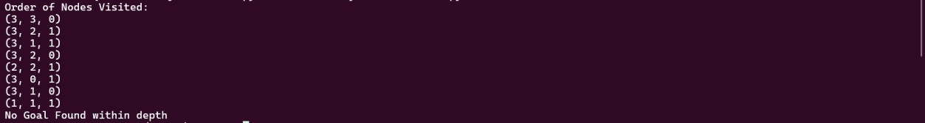
OUTPUT:

MISSIONARY CANNIBALS PROBLEM – ITERATIVE DEEPENING SEARCH

CODE:
def is_valid(state): m_left, c_left, _ = state m_right = 3 - m_left c_right = 3 - c_left
if not (0 <= m_left <= 3 and 0 <= c_left <= 3): return False
if m_left > 0 and m_left < c_left: return False
if m_right > 0 and m_right < c_right: return False
return True
def get_successors(state): m, c, b = state
moves = [(1,0), (2,0), (0,1), (0,2), (1,1)]
successors = []
for dm, dc in moves: if b == 0:
new_state = (m - dm, c - dc, 1) else:
new_state = (m + dm, c + dc, 0)
if is_valid(new_state): successors.append(new_state)
return successors
def reconstruct_path(parent, goal, start): path = [goal]
while goal in parent: goal = parent[goal] path.append(goal)
path.reverse() return path
def print_path(path): print("Path to Goal:") for step in path:
print(step)
def ids_mc(start, goal, max_depth=20): for depth in range(max_depth):
print(f"\nDepth Limit: {depth}") visited = set()
parent = {}
def dls(state, limit): visited.add(state) print(state)
if state == goal: return True
if limit == 0: return False
for neighbor in get_successors(state): if neighbor not in visited:
parent[neighbor] = state if dls(neighbor, limit - 1):
return True return False
if dls(start, depth): print("Goal Reached")
path = reconstruct_path(parent, goal, start) print_path(path)
return
print("No Goal Found") start = (3, 3, 0)
goal = (0, 0, 1) ids_mc(start,goal,100)

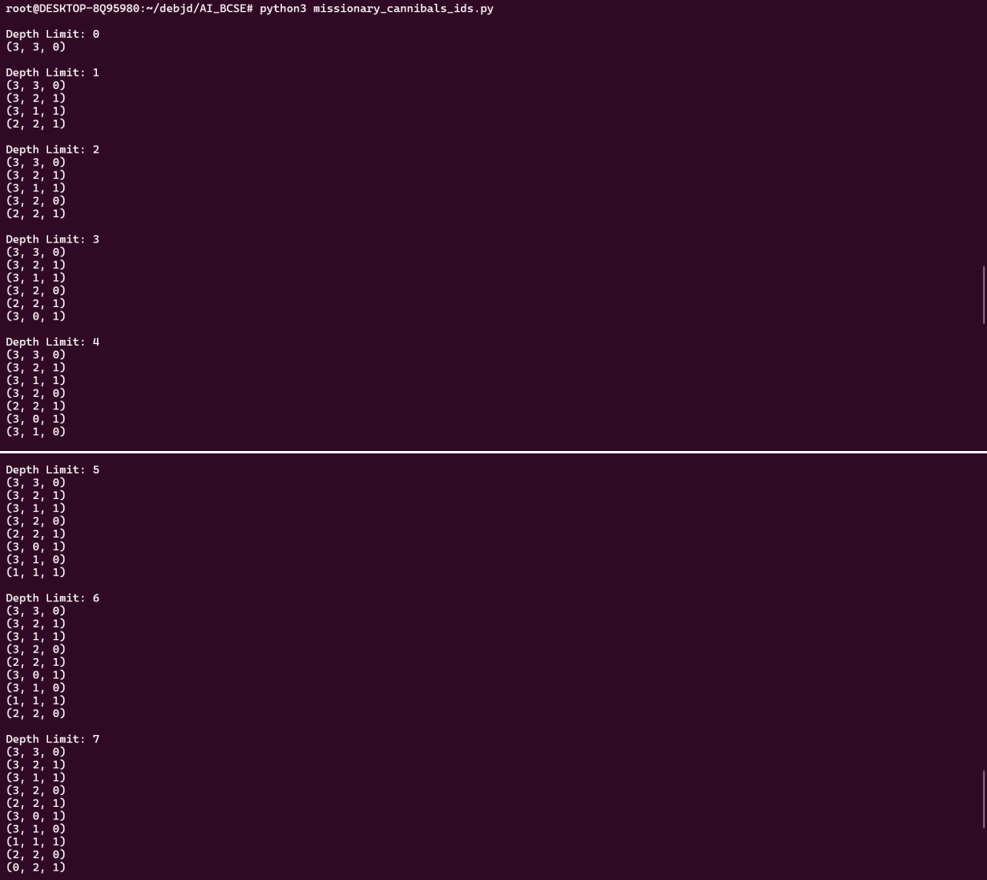
OUTPUT:

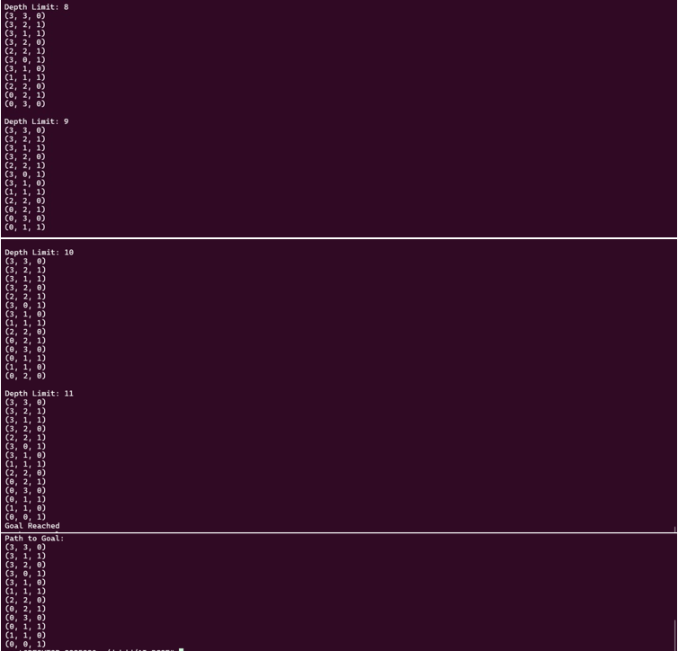

MISSIONARY CANNIBALS PROBLEM – ITERATIVE BROADENING SEARCH

CODE:
from collections import deque def is_valid(state):
m_left, c_left, _ = state m_right = 3 - m_left c_right = 3 - c_left
if not (0 <= m_left <= 3 and 0 <= c_left <= 3): return False
if m_left > 0 and m_left < c_left: return False
if m_right > 0 and m_right < c_right: return False
return True
def get_successors(state): m, c, b = state
moves = [(1,0), (2,0), (0,1), (0,2), (1,1)]
successors = []
for dm, dc in moves:
== 0:
new_state = (m - dm, c - dc, 1) else:
new_state = (m + dm, c + dc, 0)
if is_valid(new_state): successors.append(new_state)
return successors
def reconstruct_path(parent, goal, start): path = [goal]
while goal in parent: goal = parent[goal] path.append(goal)
path.reverse() return path
def print_path(path): print("Path to Goal:") for step in path:
print(step)
def ibs_mc(start, goal, max_breadth=5):
def limited_bfs(limit): visited = set()
queue = deque([start]) parent = {} visited.add(start)
print("Order of Nodes Visited:") while queue:
current = queue.popleft() print(current)
if current == goal: print("Goal Reached")
path = reconstruct_path(parent, current, start) print_path(path)
return True
for neighbor in get_successors(current)[:limit]: if neighbor not in visited:
visited.add(neighbor) parent[neighbor] = current queue.append(neighbor)
return False
for breadth in range(1, max_breadth + 1): print(f"\nBreadth Limit: {breadth}")
if limited_bfs(breadth): return
print("No Goal Found") start = (3, 3, 0)
goal = (0, 0, 1) ibs_mc(start,goal,100)

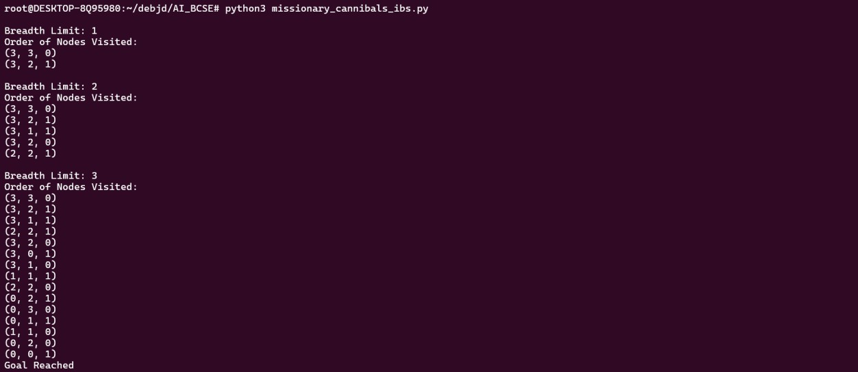
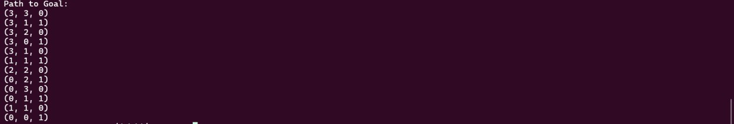
OUTPUT:

MISSIONARY CANNIBALS PROBLEM – BEST FIRST SEARCH

CODE:
def is_valid(state): m_left, c_left, _ = state m_right = 3 - m_left c_right = 3 - c_left
if not (0 <= m_left <= 3 and 0 <= c_left <= 3): return False
if m_left > 0 and m_left < c_left: return False
if m_right > 0 and m_right < c_right: return False
return True
def get_successors(state): m, c, b = state
moves = [(1,0), (2,0), (0,1), (0,2), (1,1)]
successors = []
for dm, dc in moves: if b == 0
new_state = (m - dm, c - dc, 1) else:
new_state = (m + dm, c + dc, 0)
if is_valid(new_state): successors.append(new_state)
return successors
def reconstruct_path(parent, goal, start): path = [goal]
while goal in parent: goal = parent[goal] path.append(goal)
path.reverse() return path
def print_path(path): print("Path to Goal:") for step in path:
print(step) import heapq
def best_first_mc(start, goal): def heuristic(state):
return state[0] + state[1] # people left
open_list = []
heapq.heappush(open_list, (heuristic(start), start)) visited = set()
parent = {}
print("Order of Nodes Visited:") while open_list:
_, current = heapq.heappop(open_list)
if current in visited: continue
visited.add(current) print(current)
if current == goal: print("Goal Reached")
path = reconstruct_path(parent, current, start) print_path(path)
return
for neighbor in get_successors(current): if neighbor not in visited:
parent[neighbor] = current
heapq.heappush(open_list, (heuristic(neighbor), neighbor)
print("No Goal Found") start = (3, 3, 0)
goal = (0, 0, 1) best_first_mc(start,goal)

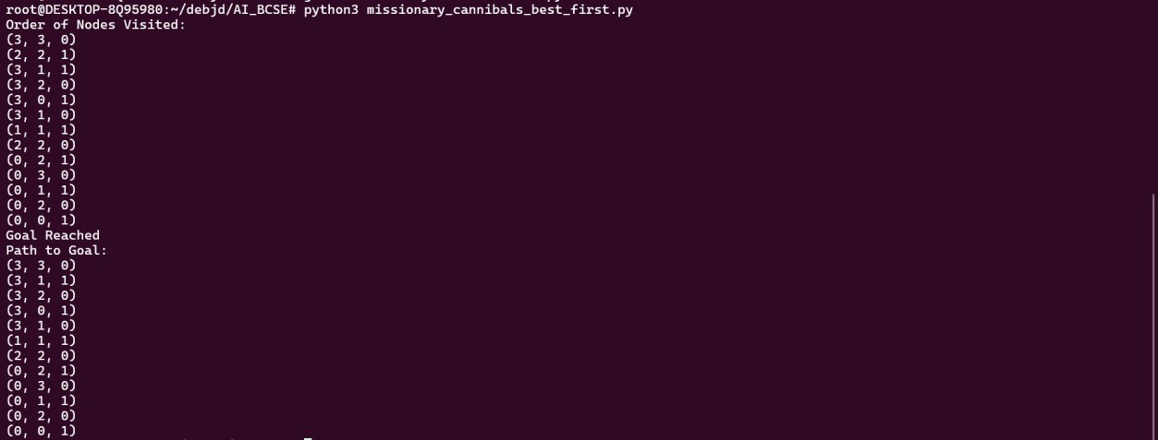
OUTPUT:

MISSIONARY CANNIBALS PROBLEM – UNIFORM COST SEARCH

CODE:
import heapq
def is_valid(state): m_left, c_left, _ = state m_right = 3 - m_left c_right = 3 - c_left
if not (0 <= m_left <= 3 and 0 <= c_left <= 3): return False
if m_left > 0 and m_left < c_left: return False
if m_right > 0 and m_right < c_right: return False
return True
def get_successors(state): m, c, b = state
moves = [(1,0), (2,0), (0,1), (0,2), (1,1)]
successors = []
for dm, dc in moves:
== 0:
new_state = (m - dm, c - dc, 1) else:
new_state = (m + dm, c + dc, 0)
if is_valid(new_state): successors.append(new_state)
return successors
def reconstruct_path(parent, goal, start): path = [goal]
while goal in parent: goal = parent[goal] path.append(goal)
path.reverse() return path
def print_path(path): print("Path to Goal:") for step in path:
print(step)
def ucs_mc(start, goal):
open_list = [] heapq.heappush(open_list, (0, start)) parent = {}
cost = {start: 0} visited = set()
print("Order of Nodes Visited:") while open_list:
curr_cost, current = heapq.heappop(open_list) if current in visited:
continue visited.add(current) print(current)
if current == goal: print("Goal Reached")
path = reconstruct_path(parent, current, start) print_path(path)
return
for neighbor in get_successors(current): new_cost = curr_cost + 1
if neighbor not in cost or new_cost < cost[neighbor]:
cost[neighbor] = new_cost parent[neighbor] = current
heapq.heappush(open_list, (new_cost, neighbor)
print("No Goal Found") start = (3, 3, 0)
goal = (0, 0, 1) ucs_mc(start,goal)

OUTPUT:
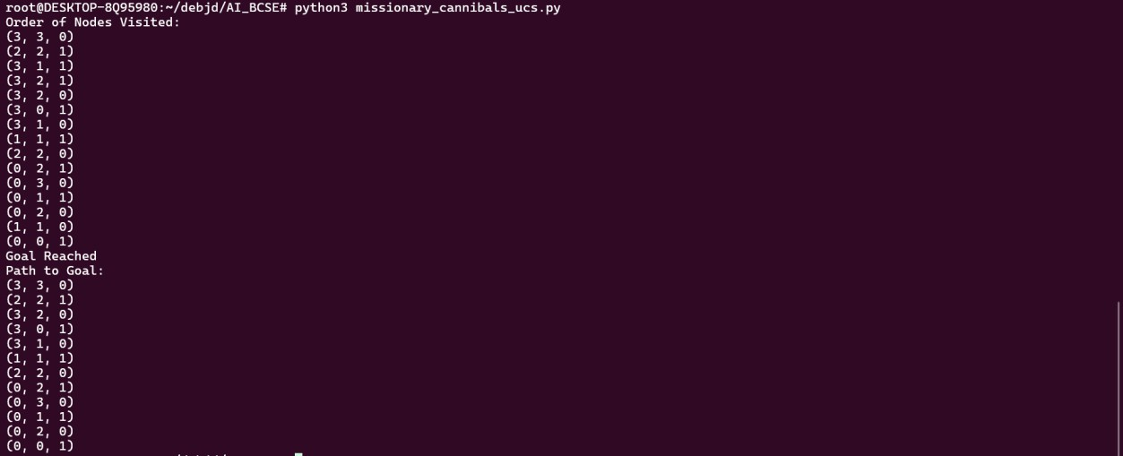

MISSIONARY CANNIBALS PROBLEM – A* SEARCH

CODE:
import heapq
def is_valid(state): m_left, c_left, _ = state m_right = 3 - m_left c_right = 3 - c_left
if not (0 <= m_left <= 3 and 0 <= c_left <= 3): return False
if m_left > 0 and m_left < c_left: return False
if m_right > 0 and m_right < c_right: return False
return True
def get_successors(state): m, c, b = state
moves = [(1,0), (2,0), (0,1), (0,2), (1,1)]
successors = []
for dm, dc in moves: if b == 0:
new_state = (m - dm, c - dc, 1) else:
new_state = (m + dm, c + dc, 0)
if is_valid(new_state): successors.append(new_state)
return successors
def reconstruct_path(parent, goal, start): path = [goal]
while goal in parent: goal = parent[goal] path.append(goal)
path.reverse() return path
def print_path(path): print("Path to Goal:") for step in path:
print(step)
def a_star_mc(start, goal): def heuristic(state):
return state[0] + state[1] # total left
open_list = []
heapq.heappush(open_list, (heuristic(start), 0, start)) parent = {}
cost = {start: 0} visited = set()
print("Order of Nodes Visited:") while open_list:
f, g, current = heapq.heappop(open_list)

if current in visited: continue
visited.add(current) print(current)
if current == goal: print("Goal Reached")
path = reconstruct_path(parent, current, start) print_path(path)
return
neighbor in get_successors(current): new_cost = g + 1
if neighbor not in cost or new_cost < cost[neighbor]: cost[neighbor] = new_cost
parent[neighbor] = current
heapq.heappush(open_list, (new_cost + heuristic(neighbor), new_cost, neighbor))
print("No Goal Found") start = (3, 3, 0)
goal = (0, 0, 1) a_star_mc(start,goal)

OUTPUT:
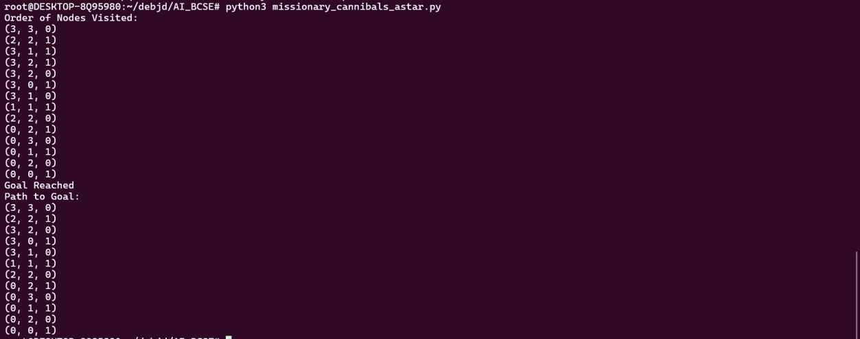

MAZE PROBLEM INPUT
We'll represent the maze as a 2D grid:
• 0 = open path
• 1 = wall
• We move in 4 directions (up, down, left, right)
• Each state is (row, col)
• Start and goal are coordinate tuples (0, 0) and (4, 4) MAZE:
maze = [
[0, 1, 0, 0, 0],
[0, 1, 0, 1, 0],
[0, 0, 0, 1, 0],
[1, 1, 0, 0, 0],
[0, 0, 0, 1, 0]
]

MAZE PROBLEM – BREADTH FIRST SEARCH

CODE:
def get_neighbors_maze(state, maze): rows, cols = len(maze), len(maze[0]) r, c = state
moves = [(-1,0), (1,0), (0,-1), (0,1)]
neighbors = []
for dr, dc in moves:
nr, nc = r + dr, c + dc
if 0 <= nr < rows and 0 <= nc < cols and maze[nr][nc] ==
0:
neighbors.append((nr, nc)) return neighbors
def reconstruct_path(parent, goal, start): path = [goal]
while goal in parent: goal = parent[goal] path.append(goal)
path.reverse() return path
def print_path(path): print("Path to Goal:") for step in path:
print(step)
from collections import deque
def bfs_maze(maze, start, goal): visited = set()
queue = deque([start]) parent = {}
print("Order of Nodes Visited:") visited.add(start)
while queue:
current = queue.popleft() print(current)
if current == goal: print("Goal Reached")
path = reconstruct_path(parent, current, start) print_path(path)
return
for neighbor in get_neighbors_maze(current, maze): if neighbor not in visited:
visited.add(neighbor) parent[neighbor] = current queue.append(neighbor)
print("No Goal Found") maze = [
[0, 1, 0, 0, 0],
[0, 1, 0, 1, 0],
[0, 0, 0, 1, 0],
[1, 1, 0, 0, 0],
[0, 0, 0, 1, 0]
]
start = (0, 0)
goal = (4, 4)
bfs_maze(maze, start, goal)

Output:
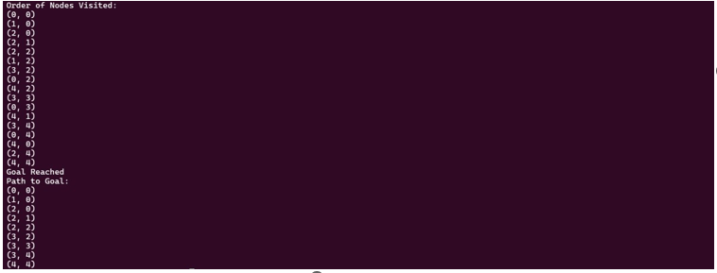

MAZE PROBLEM – DEPTH FIRST SEARCH

CODE:
def get_neighbors_maze(state, maze): rows, cols = len(maze), len(maze[0]) r, c = state
moves = [(-1,0), (1,0), (0,-1), (0,1)]
neighbors = []
for dr, dc in moves:
nr, nc = r + dr, c + dc
if 0 <= nr < rows and 0 <= nc < cols and maze[nr][nc] ==
0:
neighbors.append((nr, nc)) return neighbors
def reconstruct_path(parent, goal, start): path = [goal]
while goal in parent: goal = parent[goal] path.append(goal)
path.reverse() return path
def print_path(path): print("Path to Goal:") for step in path:
print(step)
def dfs_maze(maze, start, goal): stack = [start]
visited = set() parent = {}
print("Order of Nodes Visited:")
while stack:
current = stack.pop() if current in visited:
continue visited.add(current) print(current)
if current == goal: print("Goal Reached")
path = reconstruct_path(parent, current, start) print_path(path)
return
for neighbor in reversed(get_neighbors_maze(current, maze)):
if neighbor not in visited: parent[neighbor] = current stack.append(neighbor)
print("No Goal Found") maze = [
[0, 1, 0, 0, 0],
[0, 1, 0, 1, 0],
[0, 0, 0, 1, 0],
[1, 1, 0, 0, 0],
[0, 0, 0, 1, 0]
]
start = (0, 0)
goal = (4, 4)
dfs_maze(maze, start, goal)

Output:
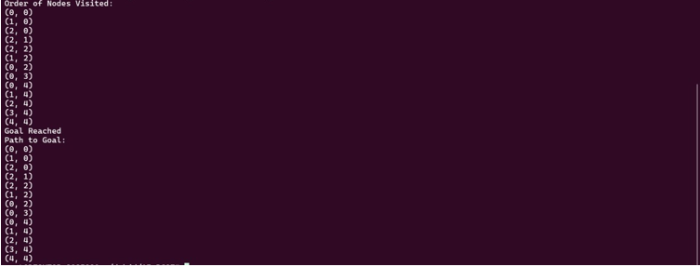

MAZE PROBLEM – DEPTH LIMITED SEARCH

CODE:
def get_neighbors_maze(state, maze): rows, cols = len(maze), len(maze[0]) r, c = state
moves = [(-1,0), (1,0), (0,-1), (0,1)]
neighbors = []
for dr, dc in moves:
nr, nc = r + dr, c + dc
if 0 <= nr < rows and 0 <= nc < cols and maze[nr][nc] ==0:
neighbors.append((nr, nc)) return neighbors
def reconstruct_path(parent, goal, start): path = [goal]
while goal in parent: goal = parent[goal] path.append(goal)
path.reverse() return path
def print_path(path): print("Path to Goal:") for step in path:
print(step)
def dls_maze(maze, start, goal, limit): visited = set()
parent = {}
def recursive_dls(state, depth): visited.add(state) print(state)
if state == goal: return True
if depth == 0: return False
for neighbor in get_neighbors_maze(state, maze): if neighbor not in visited:
parent[neighbor] = state
if recursive_dls(neighbor, depth - 1): return True
return False
print("Order of Nodes Visited:")
if recursive_dls(start, limit): print("Goal Reached")
path = reconstruct_path(parent, goal, start) print_path(path)
else:
print("No Goal Found within depth") maze = [
[0, 1, 0, 0, 0],
[0, 1, 0, 1, 0],
[0, 0, 0, 1, 0],
[1, 1, 0, 0, 0],
[0, 0, 0, 1, 0]
]
start = (0, 0)
goal = (4, 4)
dls_maze(maze, start, goal,5)

OUTPUT:
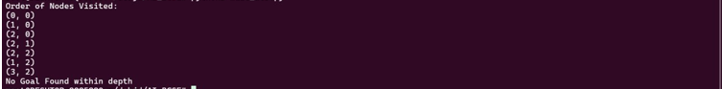

MAZE PROBLEM – ITERATIVE DEEPENING SEARCH

CODE:
def get_neighbors_maze(state, maze): rows, cols = len(maze), len(maze[0]) r, c = state
moves = [(-1,0), (1,0), (0,-1), (0,1)]
neighbors = []
for dr, dc in moves:
nr, nc = r + dr, c + dc
if 0 <= nr < rows and 0 <= nc < cols and maze[nr][nc] ==0:
neighbors.append((nr, nc)) return neighbors
def reconstruct_path(parent, goal, start): path = [goal]
while goal in parent: goal = parent[goal] path.append(goal)
path.reverse() return path
def print_path(path): print("Path to Goal:") for step in path:
print(step)
def ids_maze(maze, start, goal, max_depth=50): for depth in range(max_depth):
print(f"\nDepth Limit: {depth}") visited = set()
parent = {}
def dls(state, limit): visited.add(state) print(state)
if state == goal: return True
if limit == 0: return False
for neighbor in get_neighbors_maze(state, maze): if neighbor not in visited:
parent[neighbor] = state if dls(neighbor, limit - 1):
return True
return False
if dls(start, depth): print("Goal Reached")
path = reconstruct_path(parent, goal, start) print_path(path)
return

print("No Goal Found") maze = [
[0, 1, 0, 0, 0],
[0, 1, 0, 1, 0],
[0, 0, 0, 1, 0],
[1, 1, 0, 0, 0],
[0, 0, 0, 1, 0]
]
start = (0, 0)
goal = (4, 4)
ids_maze(maze, start, goal,100)

OUTPUT:
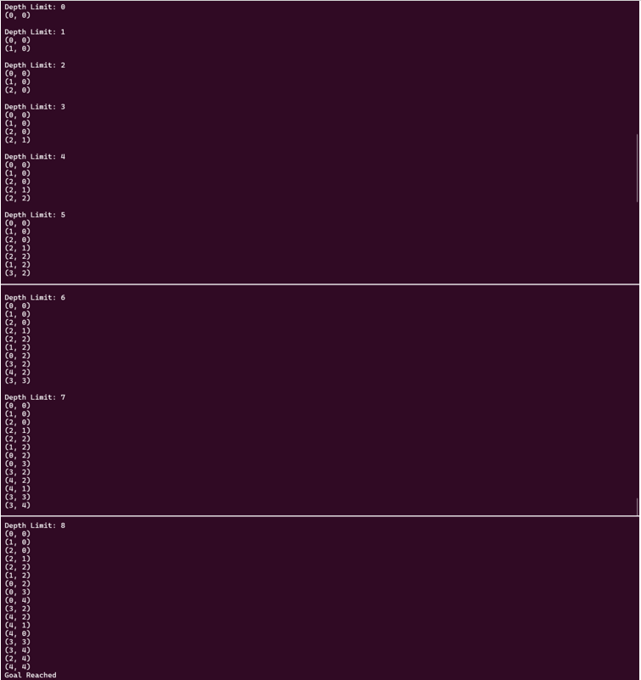
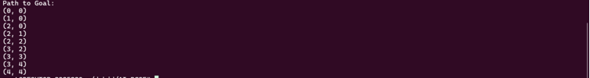

MAZE PROBLEM – ITERATIVE BROADENING SEARCH

CODE:
from collections import deque
def get_neighbors_maze(state, maze): rows, cols = len(maze), len(maze[0]) r, c = state
moves = [(-1,0), (1,0), (0,-1), (0,1)]
neighbors = []
for dr, dc in moves:
nr, nc = r + dr, c + dc
if 0 <= nr < rows and 0 <= nc < cols and maze[nr][nc] ==0:
neighbors.append((nr, nc)) return neighbors
def reconstruct_path(parent, goal, start): path = [goal]
while goal in parent: goal = parent[goal] path.append(goal)
path.reverse()
path
def print_path(path): print("Path to Goal:") for step in path:
print(step)
def ibs_maze(maze, start, goal, max_breadth=5): def limited_bfs(limit):
visited = set()
queue = deque([start]) parent = {} visited.add(start)
print("Order of Nodes Visited:") while queue:
current = queue.popleft() print(current)
if current == goal: print("Goal Reached")
path = reconstruct_path(parent, current, start) print_path(path)
return True
for neighbor in get_neighbors_maze(current, maze)[:limit]:
if neighbor not in visited: visited.add(neighbor) parent[neighbor] = current queue.append(neighbor)
return False

for breadth in range(1, max_breadth + 1): print(f"\nBreadth Limit: {breadth}")
if limited_bfs(breadth): return
print("No Goal Found") maze = [
[0, 1, 0, 0, 0],
[0, 1, 0, 1, 0],
[0, 0, 0, 1, 0],
[1, 1, 0, 0, 0],
[0, 0, 0, 1, 0]
]
start = (0, 0)
goal = (4, 4)
ibs_maze(maze, start, goal,100)

OUTPUT:
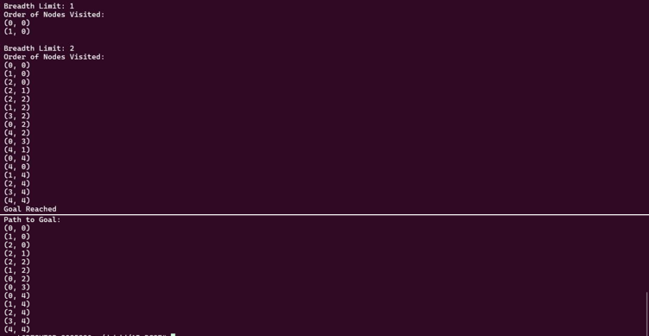

MAZE PROBLEM – BEST FIRST SEARCH

CODE:
def get_neighbors_maze(state, maze): rows, cols = len(maze), len(maze[0]) r, c = state
moves = [(-1,0), (1,0), (0,-1), (0,1)]
neighbors = []
for dr, dc in moves:
nr, nc = r + dr, c + dc
if 0 <= nr < rows and 0 <= nc < cols and maze[nr][nc] ==0:
neighbors.append((nr, nc)) return neighbors
def reconstruct_path(parent, goal, start): path = [goal]
while goal in parent: goal = parent[goal] path.append(goal)
path.reverse() return path
def print_path(path): print("Path to Goal:") for step in path:
print(step) import heapq
def best_first_maze(maze, start, goal): def heuristic(a, b):
return abs(a[0] - b[0]) + abs(a[1] - b[1])
open_list = []
heapq.heappush(open_list, (heuristic(start, goal), start)) visited = set()
parent = {}
print("Order of Nodes Visited:") while open_list:
_, current = heapq.heappop(open_list)
if current in visited: continue
visited.add(current) print(current)
if current == goal: print("Goal Reached")
path = reconstruct_path(parent, current, start) print_path(path)
return
for neighbor in get_neighbors_maze(current, maze): if neighbor not in visited:
parent[neighbor] = current
heapq.heappush(open_list, (heuristic(neighbor, goal), neighbor))
print("No Goal Found") maze = [
[0, 1, 0, 0, 0],
[0, 1, 0, 1, 0],
[0, 0, 0, 1, 0],
[1, 1, 0, 0, 0],
[0, 0, 0, 1, 0]
]
start = (0, 0)
goal = (4, 4)
best_first_maze(maze, start, goal)

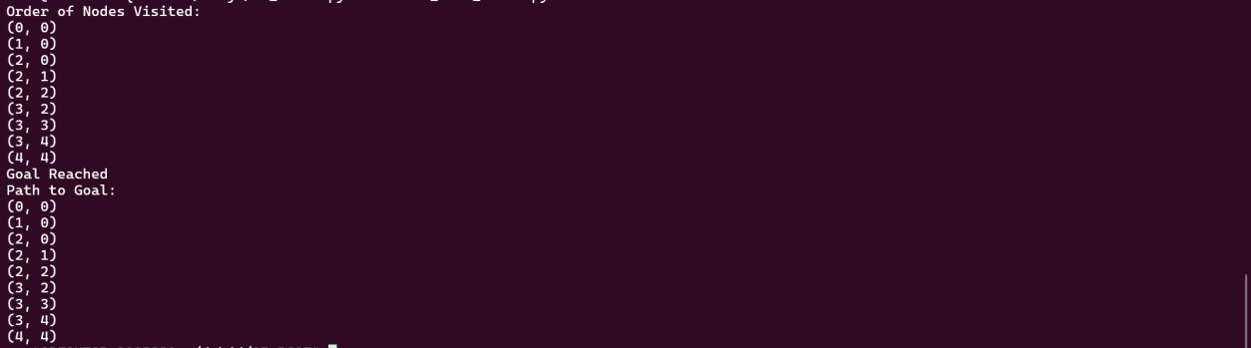
OUTPUT:

MAZE PROBLEM – UNIFORM COST SEARCH

CODE:
import heapq
def get_neighbors_maze(state, maze): rows, cols = len(maze), len(maze[0]) r, c = state
moves = [(-1,0), (1,0), (0,-1), (0,1)]
neighbors = []
for dr, dc in moves:
nr, nc = r + dr, c + dc
if 0 <= nr < rows and 0 <= nc < cols and maze[nr][nc] ==0:
neighbors.append((nr, nc)) return neighbors
def reconstruct_path(parent, goal, start): path = [goal]
while goal in parent: goal = parent[goal] path.append(goal)
path.reverse() return path
def print_path(path): print("Path to Goal:") for step in path:
print(step)
def ucs_maze(maze, start, goal): open_list = [] heapq.heappush(open_list, (0, start)) parent = {}
cost = {start: 0} visited = set()
print("Order of Nodes Visited:") while open_list:
curr_cost, current = heapq.heappop(open_list) if current in visited:
continue visited.add(current) print(current)
if current == goal: print("Goal Reached")
path = reconstruct_path(parent, current, start)
print_path(path) return
for neighbor in get_neighbors_maze(current, maze): new_cost = curr_cost + 1
if neighbor not in cost or new_cost < cost[neighbor]: cost[neighbor] = new_cost
parent[neighbor] = current heapq.heappush(open_list, (new_cost, neighbor))
print("No Goal Found") maze = [
[0, 1, 0, 0, 0],
[0, 1, 0, 1, 0],
[0, 0, 0, 1, 0],
[1, 1, 0, 0, 0],
[0, 0, 0, 1, 0]
]
start = (0, 0)
goal = (4, 4)
ucs_maze(maze, start, goal)

Output:
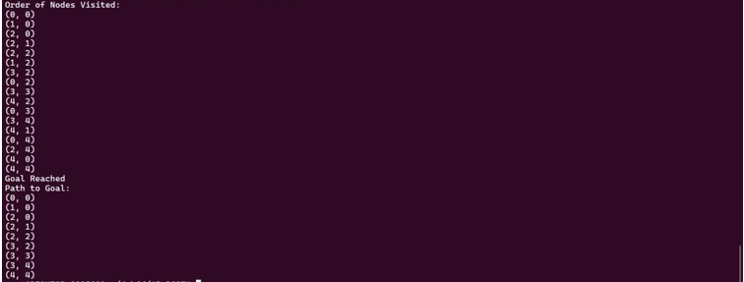

MAZE PROBLEM – A* SEARCH

CODE:
import heapq
def get_neighbors_maze(state, maze): rows, cols = len(maze), len(maze[0]) r, c = state
moves = [(-1,0), (1,0), (0,-1), (0,1)]
neighbors = []
for dr, dc in moves:
nr, nc = r + dr, c + dc
if 0 <= nr < rows and 0 <= nc < cols and maze[nr][nc] ==0:
neighbors.append((nr, nc)) return neighbors
def reconstruct_path(parent, goal, start): path = [goal]
while goal in parent: goal = parent[goal] path.append(goal)
path.reverse() return path
def print_path(path): print("Path to Goal:") for step in path:
print(step)
def a_star_maze(maze, start, goal): def heuristic(a, b):
return abs(a[0] - b[0]) + abs(a[1] - b[1])
open_list = []
heapq.heappush(open_list, (heuristic(start, goal), 0, start)) parent = {}
cost = {start: 0} visited = set()
print("Order of Nodes Visited:") while open_list:
f, g, current = heapq.heappop(open_list)
if current in visited: continue
visited.add(current) print(current)
if current == goal: print("Goal Reached")
path = reconstruct_path(parent, current, start) print_path(path)
return

for neighbor in get_neighbors_maze(current, maze): new_cost = g + 1
if neighbor not in cost or new_cost < cost[neighbor]: cost[neighbor] = new_cost
parent[neighbor] = current
f_score = new_cost + heuristic(neighbor, goal) heapq.heappush(open_list, (f_score, new_cost,
neighbor))
print("No Goal Found") maze = [
[0, 1, 0, 0, 0],
[0, 1, 0, 1, 0],
[0, 0, 0, 1, 0],
[1, 1, 0, 0, 0],
[0, 0, 0, 1, 0]
start = (0, 0)
goal = (4, 4)
a_star_maze(maze, start, goal)

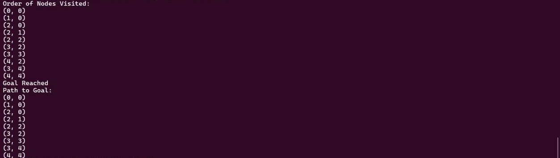
OUTPUT:

OPTIMIZATION ALGORITHMS

INPUT:
x⋅sin(10πx)+1. Find the max in[0,1]
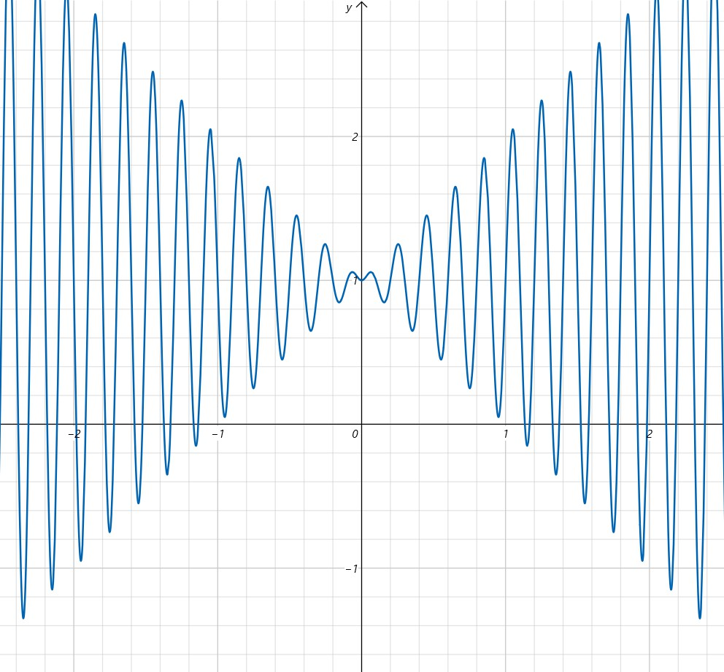

Code:
import math import random
import matplotlib.pyplot as plt
# Objective function def objective(x):
return x * math.sin(10 * math.pi * x) + 1.0
# Hill Climbing
def hill_climbing(iterations=1000, step_size=0.01): current = random.uniform(0, 1)
current_score = objective(current) history = [(0, current_score)]
for i in range(1, iterations+1):
candidate = current + random.uniform(-step_size, step_size)
candidate = min(max(candidate, 0), 1) candidate_score = objective(candidate) if candidate_score > current_score:
current, current_score = candidate, candidate_score history.append((i, current_score))
current, current_score, history
# Simulated Annealing
def simulated_annealing(iterations=1000, start_temp=1.0, alpha=0.99):
current = random.uniform(0, 1) current_score = objective(current) temp = start_temp
history = [(0, current_score)]
for i in range(1, iterations+1):
candidate = current + random.uniform(-0.1, 0.1) candidate = min(max(candidate, 0), 1) candidate_score = objective(candidate)
if candidate_score > current_score or math.exp((candidate_score - current_score) / temp) > random.random():
current, current_score = candidate, candidate_score temp *= alpha
history.append((i, current_score)) return current, current_score, history
# Genetic Algorithm
def genetic_algorithm(pop_size=20, generations=1000, mutation_rate=0.01):
def crossover(p1, p2): return (p1 + p2) / 2.0
def mutate(x):
if random.random() < mutation_rate: x += random.uniform(-0.1, 0.1)
return min(max(x, 0), 1)
population = [random.uniform(0, 1) for _ in range(pop_size)]
history = []
for gen in range(generations):
scores = [(x, objective(x)) for x in population] scores.sort(key=lambda x: x[1], reverse=True) history.append((gen, scores[0][1]))
selected = [x for x, _ in scores[:pop_size // 2]] children = []
while len(children) < pop_size:
p1, p2 = random.sample(selected, 2) child = mutate(crossover(p1, p2)) children.append(child
population = children
best = max(population, key=objective) return best, objective(best), history
# Run all algorithms
hc_solution, hc_score, hc_history = hill_climbing() sa_solution, sa_score, sa_history = simulated_annealing() ga_solution, ga_score, ga_history = genetic_algorithm()
# Plotting results plt.figure(figsize=(12, 6))
plt.plot([x for x, y in hc_history], [y for x, y in hc_history], label="Hill Climbing")
plt.plot([x for x, y in sa_history], [y for x, y in sa_history], label="Simulated Annealing")
plt.plot([x for x, y in ga_history], [y for x, y in ga_history], label="Genetic Algorithm")
plt.xlabel("Iterations / Generations") plt.ylabel("Best Objective Value") plt.title("Comparison of Optimization Algorithms") plt.legend()
plt.grid(True) plt.show()
# Print final results print("\n Final Results:")
print(f"Hill Climbing:x = {hc_solution:.4f}, f(x) =
{hc_score:.4f}")
print(f"Simulated Annealing: x = {sa_solution:.4f}, f(x) ={sa_score:.4f}")
print(f"Genetic Algorithm:x = {ga_solution:.4f}, f(x) ={ga_score:.4f}")

OUTPUT:
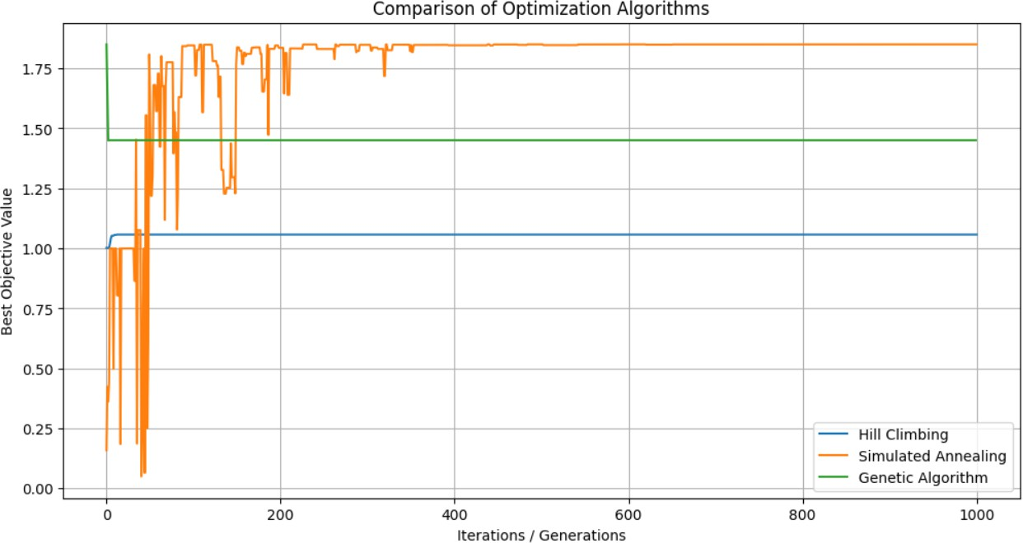

Final Results:
Hill Climbing: x = 0.0645, f(x) = 1.0579
Simulated Annealing: x = 0.8512, f(x) = 1.8506
Genetic Algorithm: x = 0.4522, f(x) = 1.4511

